 





**Store Management System**

PG-DAC SEPT 23





**Group No 101**

**239174** **Pratik Tukaram Mulik**

**239207 Shubham Namdev Belhekar**

**Mr. Harshal Waghchaure Rohit Puranik**

**Project Guide Center Corodinator**

2

**ABSTRACT**

The Store Management System (SMS) is a comprehensive software solution designed to revolutionize retail operations by automating and optimizing various processes involved in managing a store. Developed within the realm of computer science, this project aims to address the challenges faced by traditional brick-and-mortar stores in efficiently handling inventory, sales, customer data, and employee management.

**Key features of the Store Management System include:**

1. **Inventory Management:** The system facilitates real-time tracking of inventory levels, enabling store managers to monitor stock levels and automate reordering processes to prevent stockouts or overstocking.
2. **Sales and Transaction Processing:** With built-in point-of-sale (POS) functionality, the system streamlines the checkout process, allowing for swift and accurate transactions. It provides support for various payment methods, generates invoices, and maintains a record of sales transactions for future reference.
3. **Customer Relationship Management (CRM):** Store system stores customer information, purchase history, and preferences, which can be leveraged to personalize marketing efforts, enhance customer service, and foster loyalty programs.
4. **Store Management:**System admin can manage allocation of employees to the store activities with preset restrictions. Manager also can overview sales activities over selected period of time to track store progress.

Reporting and Analytics: The system offers comprehensive reporting tools that provide insights into various aspects of store operations, including sales performance, inventory turnover. These analytics empower decision-makers to identify trends, optimize strategies, and make data-driven decisions.

The Store Management System is built using modern programming languages and frameworks, ensuring scalability, reliability, and security. Its user-friendly interface makes it accessible to store managers and staff with minimal training, while its robust architecture supports integration with existing systems and future enhancements.

.

3

**ACKNOWLEDGEMENT**

Most importantly, I sincerely thank the Almighty God for giving me strength and breathe throughout the preparation of this project proposal. I also wish to extend my sincere and heartfelt gratitude to my loving mum for the financial, moral and emotional support, my classmates and friends who helped in various ways for the successful completion of this project proposal.

Finally, it is a great pleasure for me to also acknowledge the assistance and support of all the people who helped me start and finish this project proposal successfully especially Mr. Rohit Sir and Mr. Narendra Sir who has been a great supervisors during this period. I would like to give my special thanks to Mr.Harshal Sir (IACSD) for giving us enough knowledge and skills that made us to innovatively and successfully research and compile this project proposal.

Pratik Tukaram Mulik (230941220102)

Shubham Namdev Belhekar (230941220175)

4

**INDEX**

|  |  |  |
| --- | --- | --- |
| **Sr. No.** | **Title** | **Pg. No.** |
| 1 | INTRODUCTION | 5 |
| 1.1 | PURPOSE | 6 |
| 1.2 | SCOPE | 6 |
| 1.3 | OBJECTIVE OF PROJECT ON STORE MANAGEMENT SYSTEM | 7 |
| 1.4 | FUNCTIONALITIES PROVIDED BY STORE MANAGEMENT SYSTEM ARE AS FOLLOWS | 8 |
| 2 | REQUIREMENT | 9 |
| 3 | DATABAS EDESIGN | 12 |
| 4 | APPENDIX A | 15 |
| 5 | APPENDIX B | 19 |
| 6 | REFERENCES | 22 |

**5**

1. **INTRODUCTION**

In the dynamic landscape of retail, efficient management of store operations is paramount for ensuring smooth functioning and maximizing profitability. With the advent of technology, Store Management Systems have become indispensable tools for modern businesses to streamline their processes and enhance customer satisfaction.

The Store Management System (SMS) is a comprehensive software solution designed to automate and integrate various aspects of store operations, including inventory management, sales tracking, employee management, and customer relationship management. By leveraging advanced computing technologies, such as database management systems and user-friendly interfaces to optimize resource utilization, and provide actionable insights for informed decision-making.

This project endeavors to develop a robust and user-friendly Store Management System tailored to the specific needs of retail businesses. Through the implementation of key features like real-time inventory tracking, sales analytics, and customizable reporting tools, the system aims to empower store owners and managers with the tools necessary to effectively manage their operations, improve efficiency, and drive growth.

The Store Management System project will employ industry-standard software development methodologies and technologies to ensure scalability, reliability, and maintainability. Furthermore, emphasis will be placed on user experience design to create an intuitive and seamless interface that enhances usability and productivity for store staff at all levels.

Overall, the Store Management System project represents a significant step towards modernizing store operations and equipping businesses with the tools they need to thrive in today's competitive retail landscape.

6

# Purpose

In a store management system project in computer science, the purpose of the system is to efficiently manage various aspects of the store's operations. Here's a breakdown of its purposes:

**Inventory Management**: The system tracks inventory levels, updates stock quantities, and alerts when stock is running low. It helps in managing stock procurement, storage, and distribution.

**Sales Management**: It records sales transactions, generates invoices or receipts, and maintains a sales history. This helps in analyzing sales patterns, identifying popular products, and managing pricing strategies.

**Customer Management**: The system stores customer information, including contact details and purchase history. This facilitates personalized marketing, loyalty programs, and customer relationship management.

**Employee Management**: It manages employee access and activities with preset conditions. This ensures efficient management of employees.

# Scope

We believe that Online Store Management System will become even more popular in the future for the obvious reason that they save users, time and money by allowing purchase goods from anywhere, anytime.

7

# Objective of Store Management System:

When designing objectives for a store management system project in computer science, you'll want to consider both the technical and functional aspects of the system. Here are some objectives to consider:

# Functional Objectives:

# Inventory Management: Develop a system to efficiently track and manage inventory levels, including stock updates, product additions, and removals.

# Sales Tracking: Implement a feature to record sales transactions, including items sold, quantities, prices, and total revenue.

# Customer Management: Create a module for managing customer information, including profiles, purchase history, and loyalty programs if applicable.

# Reporting: Generate various reports such as sales reports, inventory status reports, profit analysis, etc., to provide insights for decision-making.

1. Technical Objectives:

# Scalability: Design the system architecture to accommodate growth and increasing transaction volumes over time.

# Reliability: Ensure the system is robust and reliable, minimizing downtime and data loss.

# Performance: Optimize system performance to ensure fast response times, even during peak usage periods.

# Project Management Objectives:

# Timeliness: Define clear milestones and deadlines to ensure the project progresses according to schedule.

# Budget Control: Manage costs effectively to prevent budget overruns and ensure the project remains financially viable.

# Stakeholder Communication: Maintain regular communication with stakeholders (e.g., store owners, end-users) to gather requirements, provide updates, and address any concerns or feedback.

# Quality Assurance: Implement rigorous testing procedures to identify and fix bugs, ensuring the system meets quality standards before deployment.

8

# Functionalities provided by Store Management System are as follows:

**Inventory Management**: This includes features for adding, updating, and deleting products in the inventory. It may also involve tracking stock levels, generating reports on inventory status, and setting up alerts for low stock levels.

**Sales Management**: This involves functionalities for processing sales transactions, including adding items to a sale, calculating the total cost, applying discounts or promotions, and generating invoices or receipts.

**Customer Management**: This includes features for managing customer information, such as storing customer details, tracking purchase history, managing loyalty programs, and generating customer reports.

**Employee Management**: This includes features for managing employee information, such as adding new employees, managing roles and permissions.

**Reporting and Analytics**: This involves functionalities for generating various reports and analyzing data related to sales, inventory, customer behavior. It may include features for creating custom reports, visualizing data, and identifying trends or patterns.

**Point of Sale (POS) System**: This is a critical functionality that enables store staff to process sales transactions directly with customers. It typically includes a user-friendly interface for adding items to a sale, accepting different payment methods.

.

These functionalities can vary depending on the specific requirements of the store and the complexity of the system being developed.

9

# REQUIREMENTS

* **Functional Requirements**

Functional requirements for a store management system project in computer science typically encompass the specific features and functionalities that the system must provide to meet the needs of the users. Here's a list of common functional requirements for such a system:

* **User Management:**
* Registration of new users (store managers, employees).
* Authentication mechanisms (login, logout).
* User roles and permissions management (admin, manager, cashier, etc.).
* **Inventory Management:**
* Add, edit, delete products.
* Tracking of product quantity (e.g., in stock, out of stock).
* **Sales Management:**
* Processing sales transactions.
* Generating invoices/receipts.
* Applying discounts and promotions.
* Sales reporting and analytics.
* **Customer Management:**
* Maintaining customer profiles.
* Loyalty programs and customer rewards.
* Tracking customer purchase history and preferences.
* **Reporting and Analytics:**
* Generating various reports (sales, inventory, profit/loss).
* Trend analysis and forecasting.
* Customizable reporting options.
* **User Interface:**
* Intuitive and user-friendly interface.
* Support for different devices (desktop, mobile, tablet).
* **Notifications and Alerts:**
* Alerts for low stock levels.
* Notification of successful transactions.

10

* **Non Functional Requirements**
* **Performance:**
* System can handle large number of users accessing system simultaneously.
* **Reliability**:
* Availability: The system should be available for use during specified hours with minimal downtime for maintenance.
* Fault tolerance: The system should be able to recover gracefully from hardware failures, software bugs, or other issues without losing data or compromising functionality.
* **Usability**:
* User interface design: The user interface should be intuitive, easy to navigate, and visually appealing.
* **Scalability**:
* The system should be able to accommodate growth in the number of products, customers, and transactions over time without requiring significant architectural changes.
* Database scalability: The database should be able to handle increasing amounts of data without performance degradation.
* **Maintainability**:
* Modularity: The system should be designed in a modular fashion, with loosely coupled components that can be modified or replaced independently.

11

**Other Requirements:**

**Hardware and Network Interfaces:**

Back-end Server Configuration:

* Intel Pentium-IV Processor
* 128MBRAM
* 1RaidControllerCard
* 32-bitEthernetController(100Base-T)
* 8x2.0GBFastSCSI/2withRaidSupport
* 2.88MBFDD
* 48xCDROMDrive
* SVGAColourMonitoronPCIwith1MBRAM
* 101KeysKeyboard
* 1MicrosoftMousewithpad
* 4/8GBDAT
* One Serial &Two Parallel Ports
* Internet Information Server (IIS)
* Microsoft Transaction Server (MTS)

Front-end Client Configuration:

* IntelPentium-III@650MHzProcessor
* 128MBSDRAM
* 10GBHardDiskDrive
* 1.44MBFloppyDiskDrive
* 15”SVGADigitalColorMonitor
* One Serial, One Parallel port, and One USB port
* 104KeysKeyboard
* PS2Mousewithpad
* 32-bitPCIEthernetCard
* 48XCDDrive

**Software Interfaces:**

Software configuration for back-end Services:

* WindowsNT–Server4.0
* SQLServer7.0

Software configuration for front-end Services:

* Virus Protection Software
* Client Workstation
* Office2000

-Web Browser–Internet Explorer/Netscape

12

# DATABASE DESIGN

**Database Design**

The following table structures depict the database design.

Table1:UserStd

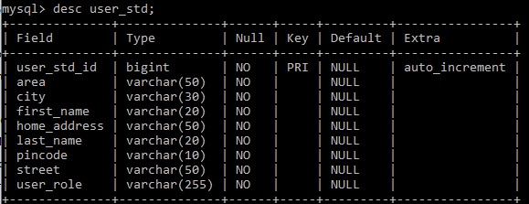

Table2:User



13

Table3:ProductStd

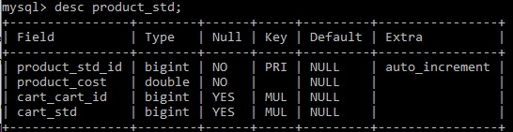

Table4:Product

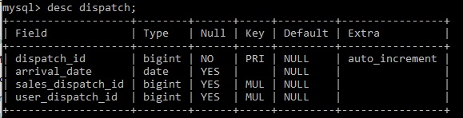

Table5:Cart

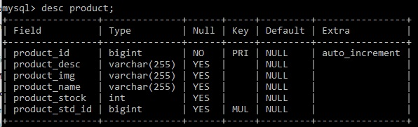

Table6:Sales

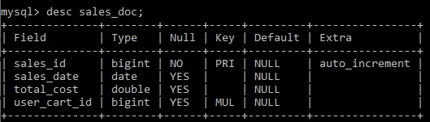

14

Table7:Dispatch



**15**

* + - 1. **APPENDIX A**

**Entity Relation Diagram-**

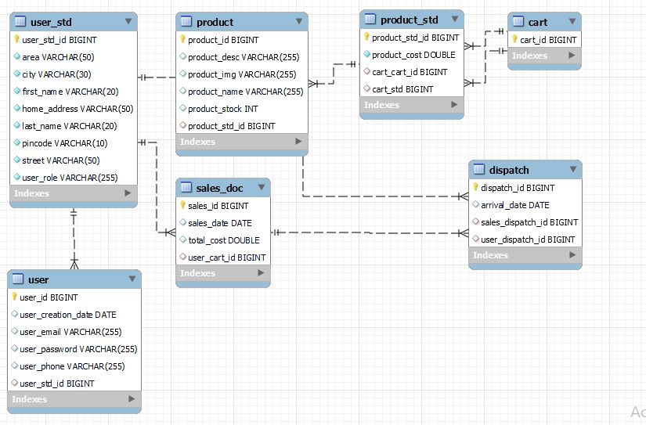

**16**

**Entity Relation Diagram-**

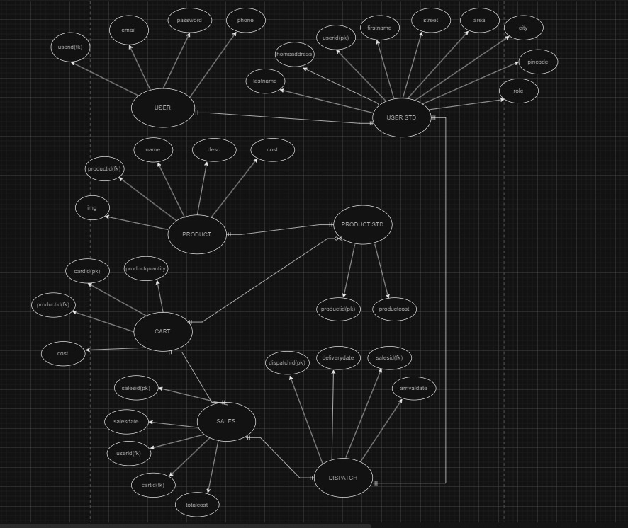

**17**

**Data Flow Diagram:**

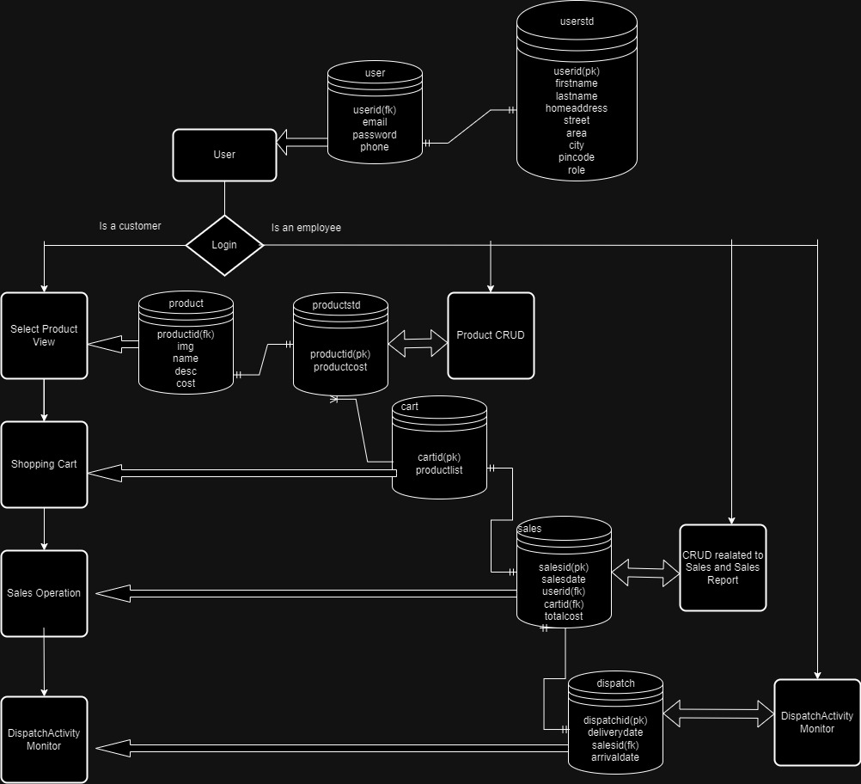

**18**

**Use Case Diagram:**

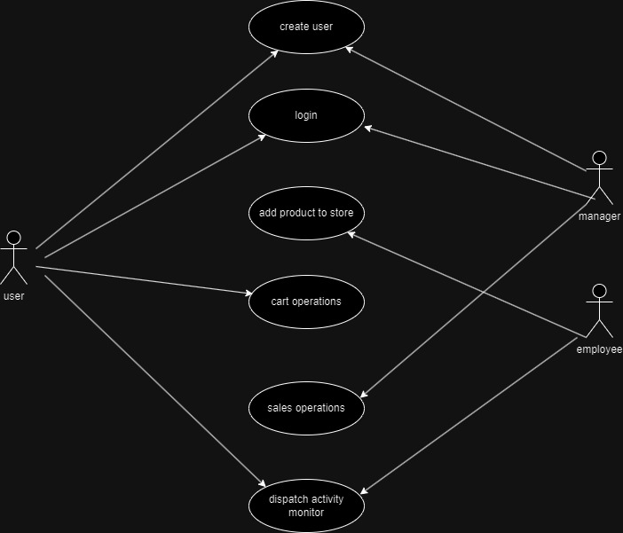

**19**

# APPENDIX B

* **Login**

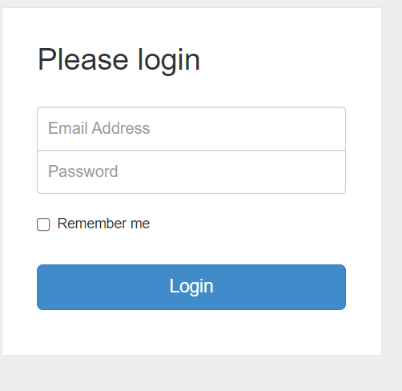

20

* **Home Page**

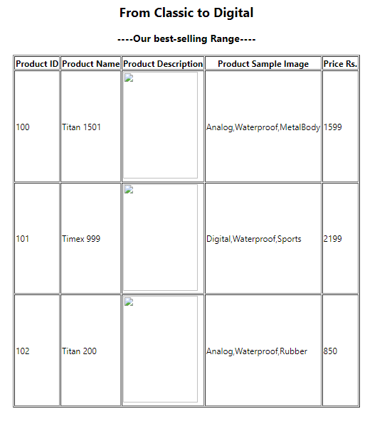

**21**

**Sales Document:**

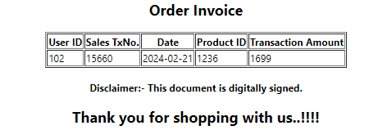

**Dispatch Details:**

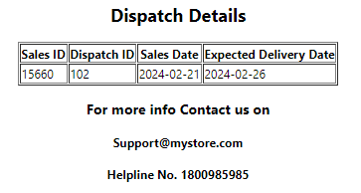

**22**

# REFERENCES

<http://www.javatpoint.com/java->tutorial[http://www.w3.org](http://www.w3.org/)[http://www.wikipedia.org](http://www.wikipedia.org/)https://[www.tutorialspoint.com/java](http://www.tutorialspoint.com/java)